3.1.1 LARGEST OF THREE NUMBERS
ALGORITHM
1 Start
2 Read three integers a, b, and c
3 If a ≥ b
- If a ≥ c
  - Set Largest = a
- Else
  - Set Largest = c
4 Else
- If b ≥ c
  - Set Largest = b
- Else
  - Set Largest = c
5 Print Largest
6 Stop

FLOWCHART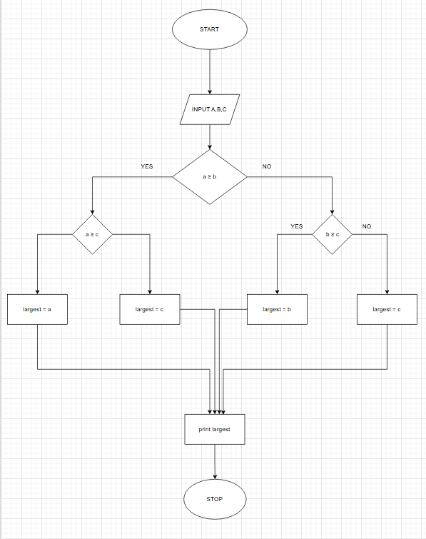
PROGRAM
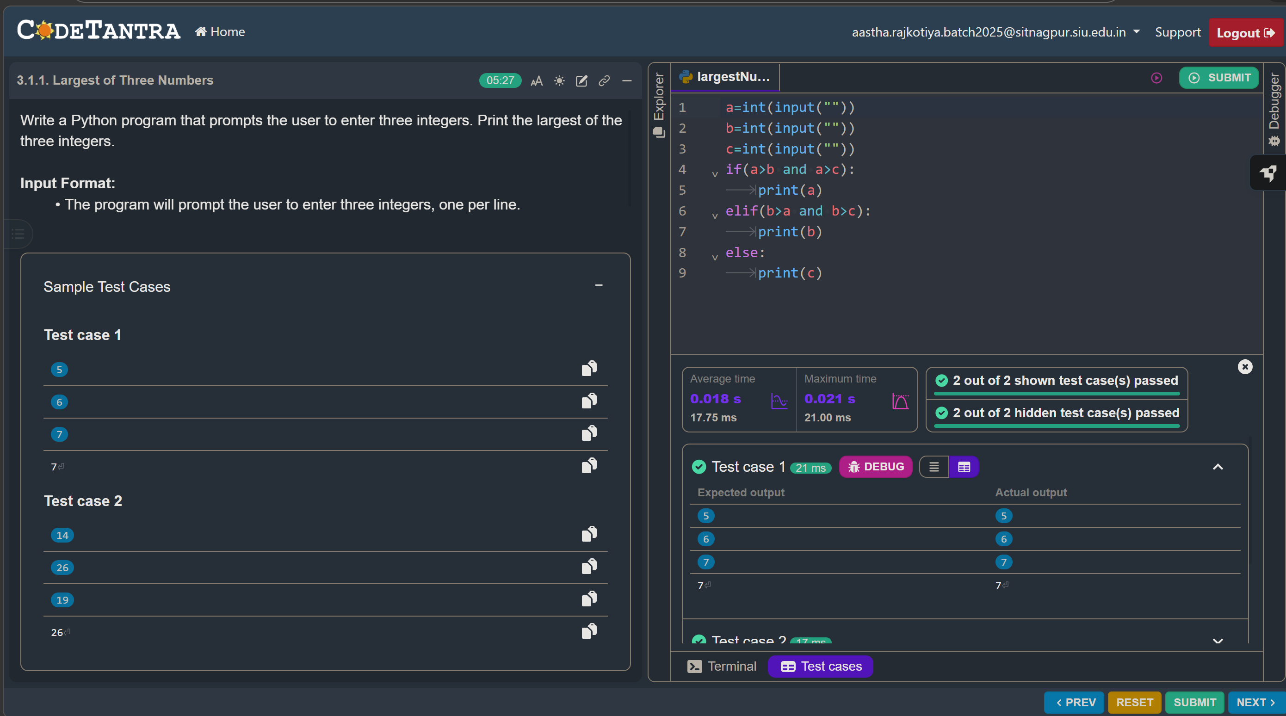

3.1.2 CELSIUS TO FAHRENHEIT
ALGORITHM
- Start
- Input temperature in Celsius (C)
- Calculate Fahrenheit using the formula
F = (C × 9/5) + 32
- Display Fahrenheit value (formatted to 2 decimal places)
- End
FLOWCHART
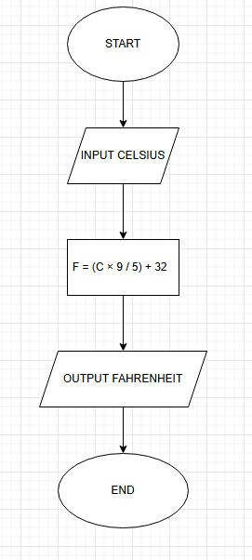
PROGRAM
